### DL-Powered Quality Control with a Delta Robot Arm

### Submitted by:

### (102003410) Ishan Mazumdar

### (102003404) Parush

### (102003409) Bhavya Gupta

### (102053024) Khushi Bathla

### (102003146) Anureet Kaur

### B.E. Third Year- COE

### CPG No. 1

### Under the Mentorship of

### Dr. Sachin Kansal

### Assistant Professor



### Computer Science and Engineering Department

### Thapar Institute of Engineering and Technology, Patiala

### March 2023

# ABSTRACT

Our approach to achieving our goal involves experimentation. We adapt and modify our deep learning strategy based on the provided dataset. Initially, we prioritize creating a well-augmented dataset from the user-provided data, focusing on the specific object for detection. Augmentation covers various aspects of the objects, enhancing their crucial classification features.

These augmented images are then channeled into a convolutional neural network (CNN) for training. The training process is iterative, involving adjusting model weights to minimize loss, ensuring better predictions. The model's scalability suits different datasets and objects, and its atomic training nature prohibits parameter changes during training.

For object detection, we employ the YOLOv5 model to identify objects captured by images on the conveyor belt. Initially, training images also serve to train the YOLOv5 model, a process that takes 5 to 10 minutes via the Roboflow API. Images are uploaded to the Roboflow platform, and the API enables access to model predictions. Detected object centroids are computed and saved.

Subsequently, these cropped images undergo the CNN model, offering predictions about whether the detected objects are 'good' or 'bad,' as defined. If an object needs segregation, an Arduino Uno is triggered. Centroid coordinates of the object to be segregated are passed to the model. The Arduino Uno communicates with the robotic arm, guiding it to move to the given coordinates and descend by a calculated 'z' distance, determined using stereo cameras calibrated through MATLAB. Subsequently, the robotic arm employs suction or its fingers (based on object size) to pick up and segregate the object from the rest.

In essence, our process is a blend of deep learning adjustments, YOLOv5 object detection, Arduino Uno coordination, and robotic arm action, all orchestrated to enhance quality control.

# DECLARATION

We hereby declare that the design principles and working prototype model of the project entitled **DL-Powered Quality Control with a Delta Robot Arm** is an authentic record of our own work carried out in the Computer Science and Engineering Department, TIET, Patiala, under the guidance of **Dr. Sachin Kansal** during 6th semester (2023).

Date: 27 December 2022

|  |  |  |
| --- | --- | --- |
| **Roll No** | **Name** | **Signatures** |
| 102003410 | Ishan Mazumdar |  |
| 102003404 | Parush |  |
| 102003409 | Bhavya Gupta |  |
| 102053024 | Khushi Bathla |  |
| 102003146 | Anureet Kaur |  |

*Counter Signed By:* 

Faculty Mentor:

Dr. Sachin Kansal Assistant Professor

CSED, TIET, Patiala

**ACKNOWLEDGEMENT**

We would like to express our thanks to our mentor Dr. Sachin Kansal. He has been of great helping our venture, and an indispensable resource of technical knowledge. He is truly an amazing mentor to have.

We are also thankful to Dr. Shalini Batra, Head, Computer Science and Engineering Department, entire faculty and staff of Computer Science and Engineering Department, and also our friends who devoted their valuable time and helped us in all possible ways towards successful completion of this project. We thank all those who have contributed either directly or indirectly towards this project.

Lastly, we would also like to thank our families for their unyielding love and encouragement. They always wanted the best for us and we admire their determination and sacrifice.

Date: 25 August 2023

|  |  |  |
| --- | --- | --- |
| **Roll No** | **Name** | **Signatures** |
| 102003410 | Ishan Mazumdar |  |
| 102003404 | Parush |  |
| 102003409 | Bhavya Gupta |  |
| 102053024 | Khushi Bathla |  |
| 102003146 | Anureet Kaur |  |

# LIST OF FIGURES

|  |  |  |
| --- | --- | --- |
| **Figure No.** | **Caption** | **Page No.** |
| Figure 2.2.2.1 | System Architecture | 14 |
| Figure 2.2.2.2 | Flow Diagram of system’s working | 15 |
| Figure 4.1.1 | Architecture Diagram | 23 |
| Figure 4.2.1.1 | DFD Level 0 | 24 |
| Figure 4.2.1.2 | DFD Level 1 | 24 |
| Figure 4.2.1.3 | DFD level 2 | 25 |
| Figure 4.2.2.1 | Class Diagram | 26 |
| Figure 4.2.3.1 | ER Diagram | 26 |
| Figure 4.3.1.1 | Activity Diagram | 28 |
| Figure 4.3.2.1 | Use Case Template | 29 |
| Figure 4.3.3.1 | State Diagram | 32 |
| Figure 5.1.1 | Experimental Setup | 33 |
| Figure 5.3.1 | Methodology | 36 |
| Figure 5.3.4.1 | Bad Quality Chip | 37 |
| Figure 5.3.4.2 | Good Quality Chip | 37 |
| Figure 5.3.4.3 | Bad Quality Chip | 38 |
| Figure 5.3.4.4 | Good Quality Chip | 38 |
| Figure 5.3.4.5 | YOLO Architecture | 38 |
| Figure 5.3.4.6 | Chips placed on conveyor belt | 39 |
| Figure 5.3.4.7 | Predictions based on the model | 40 |
| Figure 5.4.6.1 | Testing the model | 43 |

# LIST OF TABLES

|  |  |  |
| --- | --- | --- |
| **Table No.** | **Caption** | **Page No.** |
| Table 1. | Assumptions & Constraints | 6 |
| Table 2.5 | Cost Analysis | 18 |
| Table 4. | Use Case Template | 30-31 |
| Table 7.4.1 | Assessment Metrics | 51 |
| Table 7.5.1 | Name and Role | 52 |
| Table 7.6.1 | A-K Mapping | 53 |

# LIST OF ABBREVIATIONS

|  |  |  |
| --- | --- | --- |
| **S. No.** | **Abbreviation** | **Word** |
| 1. | NLP | Natural Language Processing |
| 2. | API | Application Program Interface |
| 3. | SRS | Software Requirement Specification |
| 4. | DBMS | Data Base Management System |
| 5. | Fig | Figure |

**TABLE OF CONTENTS**

**ABSTRACT i****i**

**DECLARATION ii****i**

**ACKNOWLEDGEMENT i****v**

**LIST OF FIGURES v**

**LIST OF TABLES v****ii**

**LIST OF ABBREVIATIONS vi****ii**

**CHAPTER Page No.**

1. **INTRODUCTION 1**
   1. Project Overview 1
   2. Need Analysis 3
   3. Research Gaps 5
   4. Problem Definition and Scope 6
   5. Assumptions and Constraints 6
   6. Standards 6
   7. Approved Objectives 7
   8. Methodology 7
   9. Project Outcomes and Deliverables 8
   10. Novelty of Work 9
2. **REQUIREMENT ANALYSIS 10**
   1. Literature Survey
      1. Related Work 10
      2. Research Gaps of Existing Literature 10
      3. Detailed Problem Analysis 11
      4. Survey of tools and technologies used 11
      5. Summary 12
   2. Software Requirement Specification 12
      1. Introduction 12
         1. Purpose 13
         2. Intended Audience and Reading Suggestions 13
         3. Project Scope 13
      2. Overall Description 13
         1. Product Perspective 13
         2. Product Features 15
      3. External Interface Requirements 16
         1. User Interface 16
         2. Hardware Interface 16
         3. Software Interfaces 16
      4. Other Non-Functional Requirements 16
         1. Performance Requirements 16
         2. Safety Requirements 17
   3. Cost Analysis 18
   4. Risk Analysis 18
3. **METHODOLOGY 19**
   1. Investigative Techniques 19
   2. Proposed Solution 19
   3. Work Breakdown Structure 20
   4. Tools and Technology 20
4. **DESIGN SPECIFICATIONS 22**
   1. System Architecture 22
   2. Design Level Diagrams 23

4.2.1 DFD- 0,1,2 24

4.2.2 Class Diagram 26

4.2.3 ER Diagram 26

4.3 User Activity Diagram 28

1. **Implementation and Experimental Results 33**
   1. Experimental Setup 33
   2. Experimental Analysis 34
      1. Data 34
      2. Performance Parameters 34
   3. Working of the project 35

5.3.1 Procedural Workflow 35

5.3.2 Algorithmic Approaches Used 36

5.3.3 Project Deployment 37

5.3.4 System Screenshots 37

* 1. Testing Process 40

5.4.1 Test Plan 40

5.4.2 Features to be tested 41

5.4.3 Test Strategy 41

5.4.4 Test Techniques 41

5.4.5 Test Cases 42

5.4.6 Test Results 42

* 1. Results and Discussions 44
  2. Interferences Drawn 44
  3. Validation of Objectives 44

1. **Conclusion and Future Directions** 45

6.1 Conclusion 45

6.2 Environmental, Economic, Social Benefits 46

6.3 Reflections 47

6.4 Future Work 48

1. **Project Metrics 50**

7.1 Challenges Faced 50

* 1. Relevant Subjects 50

## 7.3 Interdisciplinary Knowledge Sharing 51

7.4 Peer Assessment Metrics 51

7.5 Role Playing and Work Schedule 52

7.6 Student Outcomes Description and Performance Indicators (A-K Mapping) 52

7.7 Brief Analytical Assessment 56

**APPENDIX A: REFERENCES APPENDIX B: PLAGIARISM REPORT**

# INTRODUCTION

## Project Overview

**1.1.1 Technical terminology**

The project focuses on advancing the quality control (QC) process for chips and chocolates through a two-part approach: product detection and product classification. Product detection entails the identification and localization of items within images, achieved through the implementation of the YOLO (You Only Look Once) algorithm, specifically YOLOV5, a version known for its improved performance. Subsequently, the project involves product classification, which categorizes identified items based on predefined criteria, such as quality or defects. Deep learning, a subset of machine learning employing neural networks with multiple layers for automated feature learning, is instrumental in both the YOLO algorithm and YOLOV5. The combination of these technologies aims to enhance the efficiency and effectiveness of the quality control process, ultimately ensuring that only high-quality products reach consumers. The integration of robotics and advanced object detection and classification techniques minimizes wastage, streamlining manufacturing processes and guaranteeing the delivery of products meeting the highest standards.

**1.1.2 Problem Statement**

In contemporary manufacturing, the assurance of product quality is paramount to meet consumer expectations and uphold industry standards. However, the conventional quality control (QC) processes for products, such as chips and chocolates, often face challenges in terms of efficiency and precision. This project addresses these challenges through a comprehensive exploration of advanced technologies, specifically focusing on the identification and categorization of defective items. The primary issue at hand is the need for a more sophisticated and automated QC system that can efficiently detect and classify products. Conventional methods may fall short in providing real-time and accurate results, leading to potential delays, increased wastage, and the delivery of subpar products to consumers. The integration of the YOLO (You Only Look Once) algorithm, particularly YOLOV5, and deep learning models offers a promising solution to enhance the QC process. The primary goal is to overcome the limitations of traditional methods by implementing a system that can not only detect products promptly but also classify them accurately based on predefined criteria. By addressing these challenges, the project aims to revolutionize the manufacturing industry's approach to QC, ensuring the efficient production of high-quality products while minimizing wastage and meeting the demands of discerning consumers.

**1.1.3 Goal**

The overarching goal of this project is to revolutionize and optimize the quality control (QC) process in manufacturing, specifically focusing on the inspection of chips and chocolates. The primary objective is to overcome the limitations and inefficiencies associated with traditional QC methods by leveraging advanced technologies, including the YOLO (You Only Look Once) algorithm, specifically YOLOV5, and deep learning models. By doing so, the project seeks to achieve the following:

* Enhanced Efficiency: Implementing a more sophisticated QC system that can efficiently detect and classify products in real-time, minimizing delays in the production process.
* Precision and Accuracy: Improving the precision and accuracy of product identification and categorization, thereby reducing the likelihood of false positives or negatives in the QC process.
* Minimized Wastage: Streamlining manufacturing processes to minimize wastage by ensuring that only high-quality products proceed to the next stages of production, reducing resource and material losses.
* Consumer Satisfaction: Delivering products of the highest standards to consumers, meeting or exceeding their expectations and bolstering the reputation of the manufacturing entity.
* Automation and Advanced Technology Integration: Integrating cutting-edge technologies, such as the YOLO algorithm and deep learning, to automate and elevate the QC process to a level where it can adapt to the dynamic demands of modern manufacturing.

**1.1.4 Solution**

The envisioned solution for optimizing the quality control (QC) process in manufacturing, with a specific focus on chips and chocolates, entails the integration of cutting-edge technologies. At the core of this solution is the application of advanced object detection techniques, specifically the YOLO (You Only Look Once) algorithm, notably YOLOV5, and deep learning models. This amalgamation aims to address the inefficiencies inherent in traditional QC methods by providing a real-time, precise, and automated system for the identification and categorization of products. The solution seeks to streamline the production workflow, ensuring that only products meeting predefined quality criteria advance to subsequent stages. By embracing automation and leveraging the capabilities of deep learning, the proposed solution not only minimizes wastage but also elevates the QC process to a level where it can adapt dynamically to the evolving demands of contemporary manufacturing. Ultimately, this innovative approach strives to redefine industry standards, delivering a QC framework that excels in efficiency, accuracy, and adherence to the highest quality benchmarks.

## Need Analysis

In today's competitive market, the importance of efficient and reliable quality control systems has become increasingly evident across various industries, particularly in the food sector. With consumers demanding high-quality products, companies constantly seek ways to reduce costs and minimize waste. As a result, the need for advanced quality control methods has become a top priority.

This is where the proposed project comes into play. This project aims to tackle the challenges of quality control by using a combination of object detection and deep learning models. By utilizing algorithms based on YOLO, the system will be able to identify defective chips and chocolates in real-time accurately.

The proposed project is highly relevant to current industry needs and builds upon the existing body of research in deep learning. There have been several studies that have investigated the use of deep learning and robotics for quality control purposes, such as using convolutional neural networks for food and beverage quality control (Gao et al., 2018) and using robotic arms for object detection and picking in logistics and warehouse operations (Li et al., 2017).

Moreover, the proposed projects can potentially revolutionize how companies approach quality control. With cutting-edge technologies, the project can help reduce the costs associated with quality control and minimize waste, thereby leading to improved customer satisfaction. Using a robotic arm in the process can also provide a significant advantage over traditional quality control methods by reducing the need for human intervention, which can result in reduced errors and improved consistency.

## Research Gaps

* + - **Unsupervised Anomaly Detection for Chip Quality**: While many existing methods focus on supervised learning to classify chips and chocolates as good, average or bad, a research gap exists in exploring unsupervised anomaly detection techniques. Investigate methods that can identify anomalies in chips and chocolates data without explicitly labeled samples, which could be valuable for detecting subtle defects or variations that might not be covered by traditional supervised approaches.
    - **Multimodal Data Fusion for Enhanced Classification**: Chips and chocolates can have various attributes, such as visual features and physical measurements. A research gap lies in investigating techniques that combine information from multiple modalities to improve classification accuracy. Explore how fusing data from different sources, such as images and sensor readings, could lead to more robust chip and chocolate quality assessment.
    - **Adversarial Attacks and Robustness in Chip Quality Models**: Research gaps exist in assessing the vulnerability of chip quality classification models to adversarial attacks. Investigate how maliciously crafted inputs could lead to misclassification or compromise the model's performance. Address the challenge of enhancing the robustness of the model against such attacks, ensuring its reliability in real-world scenarios.
    - **Few-Shot Learning for Rapid Model Adaptation**: In manufacturing, new chip and chocolate designs might emerge infrequently, resulting in limited labeled data for training. Research how few-shot learning techniques could be applied to quickly adapt the model to new chip and chocolate types with only a small number of labeled examples. This could be crucial for minimizing the time and effort required to integrate the model into production lines.
    - **Domain Adaptation for Cross-Production Line Generalization**: A research gap exists in domain adaptation techniques that enable chip and chocolate quality models trained on data from one production line to be effectively generalized to another line with potentially different characteristics. Investigate methods to mitigate the domain shift challenge and maintain the model's accuracy across diverse manufacturing environments.

## Problem Definition and Scope

The project’s aim involves detecting and classifying the objects ensuring proper quality assessment using the images captured by webcam. We are going to implement a project where an image of an object is captured by the camera using the OpenCV python library. Later on, YOLOV5 is introduced to classify the image accordingly. A bounding box is displayed around the objects detected in the image along with their label that is good, average or bad with the accuracy levels of the predicted class of image.

## Assumptions and Constraints

|  |  |
| --- | --- |
| **SR No.** | **ASSUMPTION** |
| **1** | The product in the images must be only chips and white chocolate. |
| **2** | The product in the images must not be overlapping and be separated by a minimum distance. |
| **3** | Webcam has high resolution. |

Table 1: Assumptions and Constraints

## 1.6 Standards

* + - **TensorFlow v2.9.1:** It is a free and open-source software library for machine learning and artificial intelligence. It can be used across a range of tasks but has a particular focus on training and inference of deep neural networks
    - **Python:** It is a high-level, interpreted, general-purpose programming language. Its design philosophy emphasizes code readability with the use of significant indentation.
    - **Matplotlib:** Matplotlib is a powerful and versatile plotting library for the Python programming language. It provides a wide array of customizable and high-quality 2D and 3D plotting capabilities, making it a go-to tool for data visualization and analysis.

## 1.7 Approved Objectives

The objectives of the project are:

* + - Object Detection and Classification: To develop a deep learning model capable of accurately detecting and classifying chips and chocolates based on specified criteria.
    - Quality Improvement: To improve the quality of chips and chocolates supplied to consumers by detecting and classifying defective products.
    - Real-time Processing: To implement a real-time system that can process images, providing rapid and efficient quality control.
    - The proposed project aims to achieve these objectives by using deep learning to create a sophisticated quality control system that can accurately detect and classify products and improve the quality of chips and chocolates supplied to the consumer.

## 1.8 Methodology Used

The methodology for achieving the set objectives of the proposed project can be broken down into the following steps:

* Data Collection: Collect a dataset of images of chips and chocolates for training and testing the deep learning model.

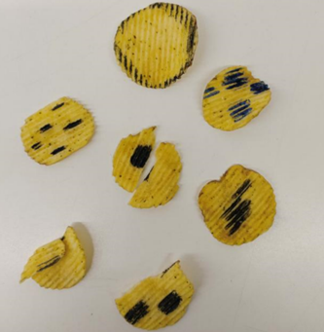 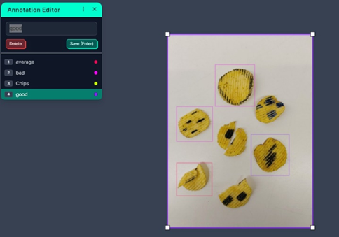

Fig. Defective chips Fig. Annotated chips using Roboflow

* + - Object Detection and Classification: Train a deep learning model based on the YOLOV5 model on the collected data. The model will be capable of accurately detecting and classifying chips and chocolates based on specified criteria.
    - Real-time Processing: Implement the system to process images in real-time, enabling rapid and efficient quality control. The deep learning model will detect and classify the chips and chocolates in real time.
    - Evaluation: Evaluate the performance of the proposed system by comparing the results with a baseline and other existing systems.
    - The methodology leverages deep learning to create a sophisticated quality control system that can accurately detect and classify products, improving the overall quality of chips and chocolates.

## Project Outcomes and Deliverables

Our project aims to control the quality of products supplied to the consumer. Our project can be majorly categorized into two parts. In this initial phase, the project aims to implement a robust product detection system utilizing the YOLOV5 algorithm. The focus is on training the deep learning model to accurately identify and locate chips and chocolates within images, laying the groundwork for subsequent classification. Product Classification: Building upon the successful detection in Phase 1, the project advances to product classification. This phase involves defining criteria for categorizing products based on quality, training an extended deep learning model, and integrating a seamless system for real-time classification of detected products, contributing to an enhanced and automated quality control process.

## Novelty Of Work

This research does not focus on one single type but rather tries to find a method to detect any given event in the dataset. A prototype capable of detecting good, average and bad chips and chocolates using the aforementioned techniques is designed for testing and evaluation purposes but can also be used as a detection tool outside the scope of this research.

# REQUIREMENT ANALYSIS

## Literature Survey

**2.1.1 Related Work**

* **Classification Algorithms and Machine Learning**: The foundation of chip quality control lies in the realm of classification algorithms. Machine learning techniques, such as decision trees, support vector machines, neural networks, and ensemble methods, have been extensively employed to differentiate between good, average and bad chips and chocolates. These algorithms leverage labeled datasets to learn patterns and make informed decisions about the product quality.
* **Anomaly Detection and Unsupervised Learning**: The theory of anomaly detection is relevant when dealing with chips and chocolates exhibiting rare or unforeseen defects. Unsupervised learning techniques, such as autoencoders and isolation forests, play a significant role in identifying anomalous patterns without relying on explicit labels. These methods can be valuable for capturing subtle variations that might not be captured by traditional supervised approaches.

**2.1.2 Research Gaps of Existing Literature**

* **Integration of YOLO Algorithm in Quality Control:** Limited exploration on the application of the YOLO (You Only Look Once) algorithm, specifically YOLOV5, in the context of quality control for consumer products like chips and chocolates. Existing literature may lack detailed insights into optimizing YOLO for efficient product detection.
* **Real-time Product Classification Techniques:** Scarcity of research addressing real-time product classification techniques following successful detection. The literature may not sufficiently explore methods for seamlessly integrating detection and classification processes, especially in the context of chips and chocolates.
* **Deep Learning Model Fine-Tuning for Product Quality:** Inadequate exploration of fine-tuning techniques for deep learning models in the quality control of food products. The literature might not provide comprehensive insights into optimizing and validating deep learning models like YOLOV5 for precise and reliable product identification.
* **Adaptation to Varied Product Types:** Scarcity of studies addressing the adaptability of the proposed system to a diverse range of food products beyond chips and chocolates. Existing literature might lack insights into the generalizability of the developed system to different types of consumables.

**2.1.3 Detailed Problem Analysis**

The existing landscape of quality control in the food manufacturing industry, particularly concerning chips and chocolates, reveals several critical gaps in research and implementation. The predominant challenge lies in the underexplored application of the YOLO (You Only Look Once) algorithm, specifically YOLOV5, for product detection, with limited insights into optimizing its performance. Additionally, there is a notable research gap in seamlessly integrating real-time product classification techniques following successful detection, especially within the context of food manufacturing. The literature lacks comprehensive exploration of criteria-based classification for consumables, hindering the establishment of precise quality benchmarks. Fine-tuning techniques for deep learning models, specifically tailored for food product quality control, are inadequately addressed. Furthermore, there is a need for industry-specific adaptation of object detection algorithms and a dearth of studies examining efficiency metrics and wastage reduction strategies associated with automated quality control. Integrating human-in-the-loop approaches and ensuring the adaptability of the proposed system to a variety of food products remain understudied aspects. Addressing these research gaps is imperative for the development of an advanced, industry-tailored quality control system that optimizes efficiency, minimizes wastage, and ensures the delivery of high-quality products to consumers.

**2.1.4 Survey of Tools and Technologies Used**

* **Roboflow for Dataset Creation and Augmentation:** Roboflow is a platform designed for managing and augmenting image datasets. It facilitates the creation of diverse and annotated datasets for training machine learning models, making it an integral tool for computer vision projects.
* **Webcam for Capturing Product Images:** A webcam is a hardware device used for capturing real-time images and videos. In this project, it serves as a practical tool for capturing product images during the quality control process.
* **Python for Code Implementation**: Python is a versatile programming language widely used in data science, machine learning, and general-purpose software development. It provides a rich ecosystem of libraries and frameworks for implementing complex algorithms and applications.
* **YOLOV5 as the Model:** YOLOV5 (You Only Look Once version 5) is an object detection model, known for its real-time processing capabilities. It breaks down an image into a grid and predicts bounding boxes and class probabilities for each grid cell.
* **OpenCV:** Used for image processing and handling webcam inputs.
* **PyTorch:** The deep learning library used for implementing and training the YOLOV5 model.
* **Matplotlib:** A plotting library utilized for visualizing results and insights during the development phase.

**2.1.5 Summary**

In building upon existing work, our project introduces a novel approach to quality control in the manufacturing of chips and chocolates. While previous efforts have explored object detection and classification, our work uniquely integrates the YOLOV5 algorithm, Roboflow for dataset management, and webcam technology for real-time image capture. The focus on leveraging advanced technologies, such as the YOLOV5 model, and integrating tools like Roboflow for efficient dataset preparation distinguishes our project. Additionally, our implementation involves a seamless combination of Python programming with key libraries like OpenCV, NumPy, and PyTorch, optimizing the entire quality control pipeline. By addressing specific research gaps in the literature, our work strives to set a new standard for precision, efficiency, and adaptability in automated quality control processes for food manufacturing.

## Software Requirement Specification

**2.2.1 Introduction**

## 2.2.1.1 Purpose

Our project aims to control the quality of products supplied to the consumer. Our project can be majorly categorized into two parts.

The first one comprises detecting the defective product based on the specified criteria after manufacturing.

The second part involves multiclass classification where we are classifying the detected products into 3 classes namely good, average and bad.

We are going to implement a project where an image of an object is captured by the camera and using the OpenCV python library. Later on, YOLOV5 is introduced to classify the image accordingly. In this project, the camera will capture an image of chips for further processing in the model based on YOLOV5. The trained model detects the object in the image, and hence classifies it. In this way, our project will recognize and classify wrong items.

## Intended Audience and Reading Suggestions

The intended audience of this document is the potential end user who wants to perform detection and classification of extremely minute objects in minimal time at minimal cost.

## Project Scope

This SRS document applies to the Capstone Project on “DL-Powered Quality Control with a Delta Robot Arm” for users who aim to detect and classify objects into good, average and bad in terms of quality.

## Overall Description

## 2.2.2.1 Product Perspective

Figure 2.2.2.1 shows the basic architecture of the solution proposed by us.

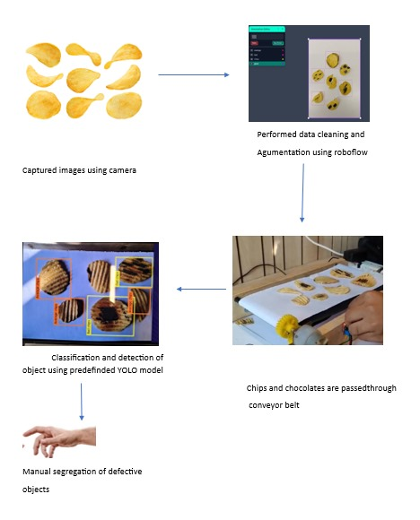

Figure 2.2.2.1 System architecture

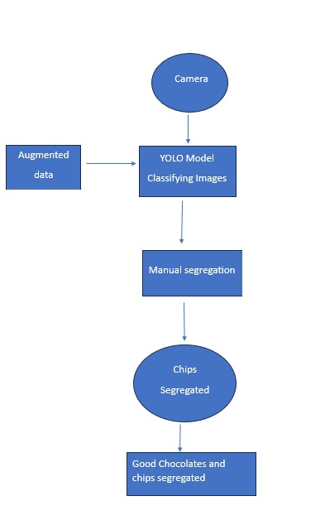

Figure 2.2.2 Flow diagram of system’s working

## 2.2.2.2 Product Features

* + **Diverse Dataset Management with Roboflow:** Utilizes Roboflow for efficient dataset creation and augmentation, providing a diverse set of annotated images crucial for training and enhancing the adaptability of the system.
  + **Real-time Classification for Immediate Decision-making:** Integrates a seamless system for immediate categorization of detected products based on predefined criteria, facilitating swift decision-making in the manufacturing process.
  + **Human-in-the-Loop Integration for Reliable Validation:** Allows for human expertise to validate and refine automated detection and classification results, ensuring the reliability of the quality control process through collaborative validation.

## 2.2.3 External Interface Requirements

**2.2.3.1 User Interface**

Image Capture Module, Dashboard

**2.2.3.2 Hardware Interface**

WebCam, Conveyer Belt

## 2.2.3.3 Software Interface

Python, TensorFlow, Roboflow

## Other Non-functional requirements

**2.2.4.1** **Performance Requirements**

The performance requirements of the project are critical to ensure that the system functions effectively, accurately detects and classifies objects, and operates seamlessly within the production environment. Here are the key performance requirements:

* **Accuracy**: The system must achieve a high level of accuracy in detecting and classifying objects to ensure effective quality control and minimize errors.
* **Real-time Processing**: The system should process images and make predictions in real-time to maintain the pace of the production line without causing delays.
* **Robustness**: The system should be robust enough to handle variations in lighting conditions, object orientations, and appearance while maintaining accurate detection and classification.
* **Integration**: The system should seamlessly integrate with existing manufacturing equipment and conveyor systems, requiring minimal modifications for smooth operation.
* **Scalability**: The system should be capable of handling changes in production rates and variations in the types of objects being processed, allowing for scalability as production demands evolve.

**2.2.4.2 Safety Requirements**

Safety is of utmost importance in any project involving robotics, automation, and industrial processes. Here are some key safety requirements for this project:

* **Emergency Stop Functionality**:

The system must have a clearly marked and easily accessible emergency stop button that immediately halts all conveyor operations in case of an emergency.

* **Safety Guards and Enclosures**:

Adequate safety guards and enclosures should be in place around the conveyor system to prevent accidental contact, ensuring that human operators are not exposed to moving parts.

* **User Training**:

All personnel involved in operating, maintaining, or interacting with the system must receive comprehensive training on safety protocols, emergency procedures, and proper operation to minimize the risk of accidents.

* **Electrical Safety Measures**:

Electrical components must adhere to safety standards to prevent electrical hazards. Proper grounding, insulation, and protection against short circuits are essential to maintain a safe working environment.

**2.2.4.3 Security Requirements**

Security is crucial to protect both the system and the data it processes. Here are 5 major security requirements for the project:

* **Access Control and Authentication**:

Implement user authentication mechanisms to ensure that only authorized personnel can access and control the system. This can involve usernames, passwords, or biometric authentication for secure access.

* **Firmware and Software Updates**:

Regularly update firmware, software, and operating systems to ensure that the latest security patches are applied, minimizing vulnerabilities that could be exploited by attackers.

* **Secure APIs and Interfaces**:

Ensure that any APIs or interfaces used to interact with the system are properly secured and authenticated to prevent unauthorized access and data leaks.

* **Regular Security Audits**:

Conduct periodic security assessments and audits to identify potential vulnerabilities in the system and take proactive measures to address them.

## 2.3 Cost Analysis

|  |  |  |
| --- | --- | --- |
| **Item** | **Quantity** | **Cost (in Rupees )** |
| Conveyor Belt | 1 | provided by our mentor. |
| Mobile Camera | 1 | 0 |
| Chips and Chocolates | 1 | 200 |

Table 2.5

## 2.4 Risk Analysis

* + - Mobile camera may not be of good resolution.
    - Model is too naive to detect differences.
    - Distance between camera and conveyor belt may change.

# METHODOLOGY ADOPTED

## Investigation Techniques

To achieve our goal, we experiment and adjust our deep learning strategy based on the provided dataset. Our initial focus is on creating a well-augmented dataset from the user-provided data, emphasizing the specific object we want to detect. We enhance various aspects of the objects in the images to improve their key features for accurate classification. These augmented images are then used to train a YOLOV5 model iteratively. During training, we adjust the model's weights to minimize loss, ensuring improved predictions. The model's scalability allows it to adapt to different datasets and objects, and its atomic training nature prevents parameter changes during the training process.

For object detection and classification, we employ the YOLOv5 model to identify and classify objects captured by images on the conveyor belt. Images are uploaded to the Roboflow platform, and its API facilitates access to the model predictions. We compute and save the centroids of detected objects. Subsequently, these images are categorized as 'good,' 'average,' or 'bad' based on predefined criteria. This process ensures a dynamic and effective quality control system.

## Proposed Solution

Our proposed solution centers around a dynamic and adaptive approach to deep learning for effective quality control in the manufacturing process. The key steps involve iterative experimentation and modification of our deep learning strategy based on the provided dataset. Initially, we prioritize the creation of a robust and well-augmented dataset derived from user-provided data, with a specific focus on the object of interest for detection. Augmentation techniques are applied comprehensively to various aspects of the objects, enhancing critical features necessary for accurate classification.

The augmented images serve as the training data for our YOLOV5 model, a powerful and versatile deep learning algorithm known for its real-time object detection capabilities. The training process is iterative, wherein we continuously adjust the model's weights to minimize loss, ensuring increasingly accurate predictions. Notably, the scalability of the YOLOV5 model allows it to adapt seamlessly to different datasets and objects. The training process follows an atomic nature, preventing parameter changes during training to maintain stability and consistency.

In the operational phase, the trained YOLOV5 model is employed for object detection and classification. Images captured on the conveyor belt are uploaded to the Roboflow platform, and the platform's API facilitates easy access to model predictions. We compute and store the centroids of detected objects, providing valuable spatial information. Subsequently, each image is classified as 'good,' 'average,' or 'bad' based on predefined criteria, offering a comprehensive assessment of product quality.

This solution not only leverages advanced technologies like YOLOV5 and Roboflow but also incorporates a continuous improvement cycle, allowing for dynamic adaptation to evolving datasets and manufacturing requirements. The proposed system ensures efficient and precise quality control, contributing to the delivery of high-quality products in a real-time manufacturing environment.

## Work Breakdown Structure

* + 1. The initial step involves doing the literature review, which involves reading several research papers. The research papers we analyzed involve working and architecture behind the YOLOV5 model.
    2. Next step involves passing the dataset to the YOLOv5 model. The dataset is also passed on to the image augmentation script, which generates new images from the given dataset. The augmented dataset is then passed to the model. Training, being an iterative process, keeps increasing its accuracy with each iteration by modifying the weights.
    3. Now the process of mobile camera takes place, in which the camera is placed at an appropriate distance from the conveyor belt and it clicks the images of the product on the belt.
    4. Now the conveyor belt starts rotating, and hence the images are sent to the YOLOv5 model, which detects the object in that image and returns its coordinate. The coordinates are stored and further used by the model to predict the class of the image.

## Tools and Technologies

Tools used in the project:

* + 1. Conveyer belt
    2. Camera

Technologies used in project:

1. PyTorch (for YoloV5)
2. Python for writing the code.
3. Roboflow for dataset creation.

# DESIGN SPECIFICATIONS

## System Architecture

Fig 4.1.1 shows the program architecture which begins with the capture of images using a camera, forming the foundational dataset for subsequent processing. Leveraging Roboflow, the dataset undergoes meticulous data cleaning and augmentation to ensure quality and diversity. In the operational phase, chips and chocolates move along a conveyor belt, and a pre trained YOLOV5 model executes real-time detection and classification of these products. The model, having learned from the augmented dataset, accurately identifies and categorizes objects. The final step involves manual segregation, where human expertise refines the automated results, ensuring the precise identification of defective products. This architecture, seamlessly integrating advanced technologies and human validation, establishes an efficient and adaptive quality control system for the manufacturing process.

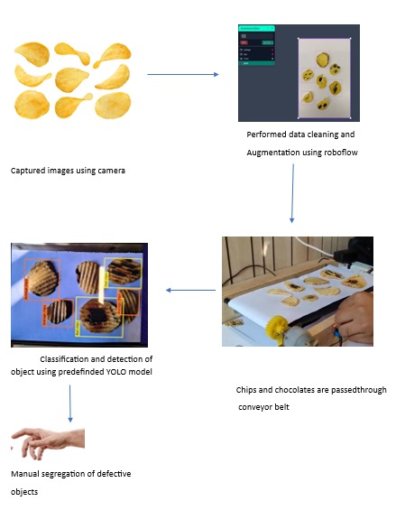

Fig 4.1.1 Architecture Diagram

# Design Level Diagrams

## Data Flow Diagram - Zero, First and Second level

**Figures 4.2.1.1 - 4.2.1.3** show the zero, first and second level of data flow diagrams. These diagrams map out the flow of information for our system and each successive diagram contains more detailed information. The entities in the diagram include functions, databases and other information.

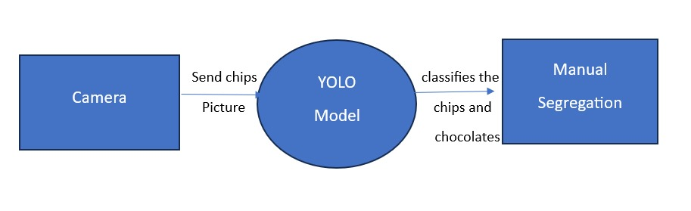

Fig 4.2.1.1 DFD Level 0

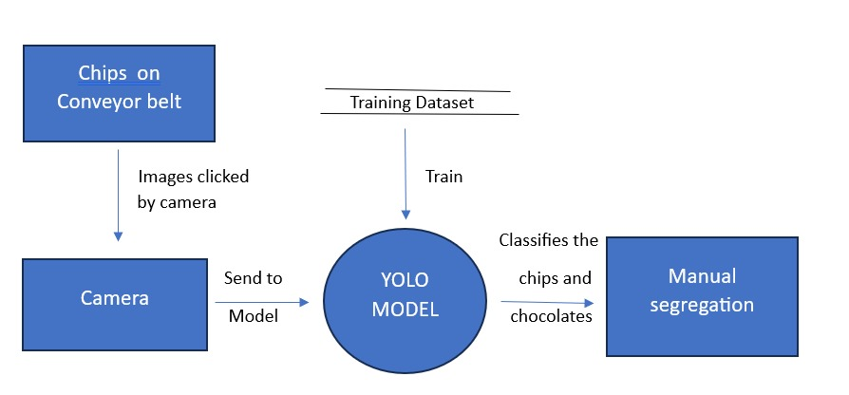

Fig 4.2.1.2 DFD Level 1



Fig 4.2.1.2 DFD Level 2

## Class Diagram

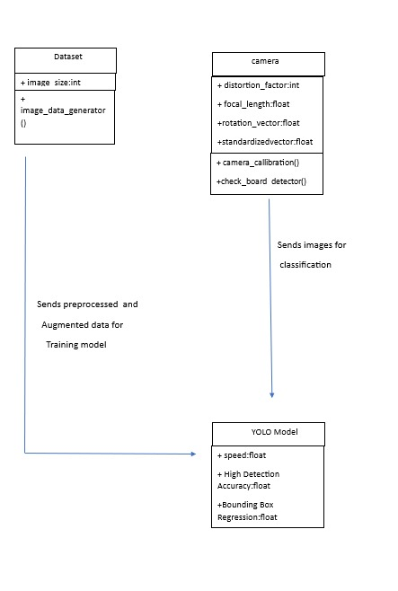

Figure 4.2.2.1 Class Diagram

## ER Diagram

**Figure 4.2.3.1** shows the ER diagram for our project. It describes various modules in our project as different Entities related to each other via certain relationships.

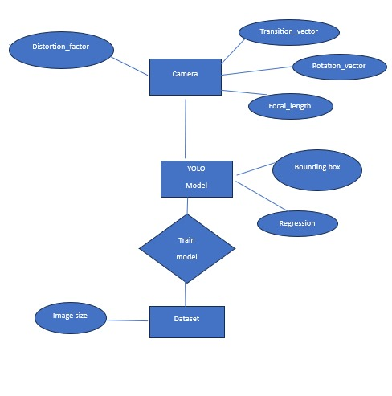

4.2.3.1 ER Diagram

# User Interface Diagram

## Activity Diagram

Chips on the conveyer belt starts rotating. When in proximity, Webcam will take the pictures of the chips. The trained YOLOV5 model will predict whether the images are good, average or bad. The results will be depicted on the phone screen. The same is depicted in Fig 4.3.1.1.

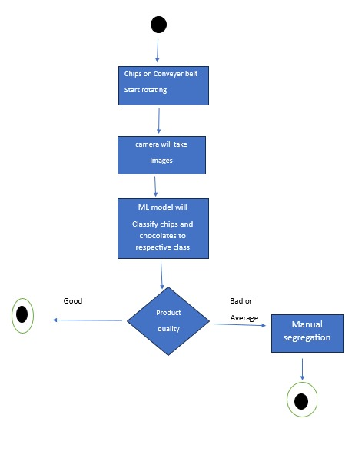

Fig 4.3.1.1 Activity Diagram

## Use Case Diagram

**Figure 4.3.2.1** shows the use case diagram for our project. This diagram summarizes the details of our system and the actors within our system.

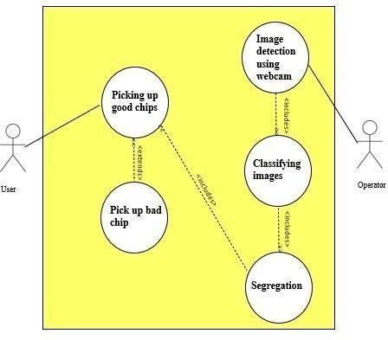 Fig 4.3.2.1 Use Case Diagram

|  |  |
| --- | --- |
| **Use Case** | Quality Control robotic arm |
| **Use Case Purpose** | The main aim is to control the quality of products supplied to the  consumer It involves creating a model capable of detecting and classifying the objects based on their quality |
| **Use case Description** | We are going to implement a project where an image of an object is captured by the camera and using the OpenCV python library. Later on, YOLOV5 is introduced to classify the image accordingly and hence the information is displayed on the phone screen. |
| **Assumptions** | * The distance between camera’s is not changing * The chips are laid in a single layer and not piled |
| **Variations** | * Advanced robotic arms can be used to make the result more efficient * Various machine learning algorithms can be used for recognition and classification. * The model can be trained for various other materials and is not limited to chips |
| **Trigger** | Conveyor belt starts rotating and the web cam starts capturing pictures |
| **Primary Actors** | YOLOV5 model |
| **Secondary Actors** | Operator |
| **Pre-Conditions** | * Model is trained with respect to the dataset * Camera is calibrated properly |

|  |  |
| --- | --- |
| **Alternate Scenario** | 1. No chip is detected as bad 2. The distance between camera’s has changed Return to normal scenario step 1 |
| **Post Conditions** | Success end condition:  1. Chips are classified accordingly  Failure end condition:  1. The model could not classify the chips |
| **Special Requirements** | 1. Quality of Camera should be good 2. The chips and chocolates must not be overlapping on the conveyor belt. |

Table 4: Use Case Template

### State Diagram

**Fig 4.3.3.1** shows the state diagram, which depicts the state of the system at any instant if time. It uses state transitions to represent the condition of the system at any given time.



Fig 4.3.3.1 State Diagram

# IMPLEMENTATION AND EXPERIMENTAL RESULTS

**5.1 Experimental Setup Simulation)**

The experimental setup consists of a yolo pytorch model, a rotating conveyor belt and a stand holding the camera for image capturing. The output of the model will be shown on the phone screen. The camera records the objects on the conveyor belt in real time. After this, the recorded frame is then passed on to the Yolov5 model for detection of chips and hence the model will classify the chips as good, average or bad. These predictions are then sent to the script which makes bounding boxes around it and then the results are outputted on the screen. The above modules used can be explained as follows:

* + 1. YoloV5: This model follows the basic structure of the YoloV5 model. We have used the YoloV5 (small) model for detection but other versions can also be used for detection based on the requirements.
    2. Camera: Used for capturing objects from the rotating conveyor belt. The camera used can also be changed according to the specific objects being used for detection and classification.

3. Conveyor Belt: The conveyor belt serves as the operational stage for image capture, facilitating the seamless movement of products for real-time detection and classification.

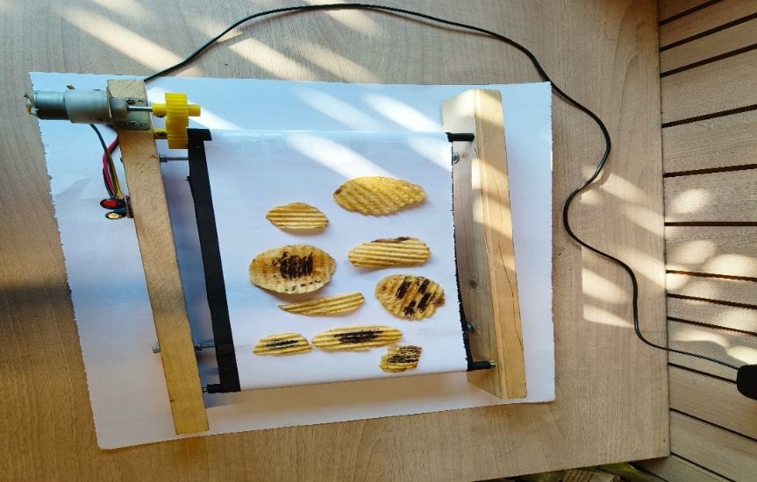

Fig 5.1.1 Experimental Setup

* 1. **Experimental Analysis**

**5.2.1 Data**

In the experimental analysis, the dataset was meticulously curated using Roboflow, starting with diverse data sources capturing real-world instances of chips and chocolates on the manufacturing line. The data cleaning process, automated through Roboflow, ensured the removal of irrelevant or low-quality images, establishing a consistent quality standard. Subsequent data pruning strategically eliminated redundancy to prevent bias and promote model generalization. The feature extraction workflow involved robust augmentation techniques, enhancing key object features for improved classification. Overall, this comprehensive approach to dataset preparation laid the foundation for the YOLOV5 model's success in accurately detecting and classifying products on the conveyor belt, reflecting real manufacturing conditions.

The dataset we used is available on this link:

<https://drive.google.com/drive/folders/1FHi9x11rd1bbukIvJAS5v5d4BZb8H6z0>

**5.2.2 Performance Parameters**

**Accuracy Measures:**

* + 1. **Detection Accuracy:** The percentage of accurately detected products on the conveyor belt. Measured by comparing the number of correctly identified products to the total number of products, providing insights into the model's ability to precisely locate objects.
    2. **Classification Accuracy:** The accuracy of correctly categorizing products into 'good,' 'average,' or 'bad' classes. Assessed by comparing the model's assigned class to the ground truth, gauging the effectiveness of the classification criteria in determining product quality.

**Quality of Service (QoS) Parameters:**

**1. Real-time Processing Speed:** The speed at which the system processes and classifies products in real-time. Evaluated in terms of frames processed per second (FPS), ensuring timely and efficient quality control on the manufacturing line.

**2. System Robustness:** The system's ability to maintain accurate detection and classification under varying lighting conditions and product orientations. Assessed through testing in simulated challenging environments, reflecting the system's resilience.

**3. Data Throughput:** The rate at which images are processed and classified through the system. Quantified in terms of the number of images processed per unit of time, ensuring optimal throughput in a high-speed manufacturing environment.

**4. Human-in-the-Loop Integration Effectiveness:** The accuracy and efficiency of human validation in refining automated detection and classification results. Assessed by comparing manually validated results to the automated system's outputs, ensuring the collaborative effectiveness of human and machine intelligence.

**5.3 Working of the project**

**5.3.1 Procedural Workflow**

The complete workflow of the project can be summarized in the following steps:

1. The first step is to create a proper dataset, having at least 50-60 images of desired objects with proper classification between the various types of them.

2. Next step is to pass the result into the YOLOv5 model. These 50-60 images will be augmented with proper augmentation techniques like cropping, rotating etc.

3. Once the YOLOv5 model is properly trained, the output of the model will give us images of desired objects. Then we will pass these images to the model for training with proper labeling which was given to us by the user.

4. Now the desired objects will be placed on the conveyor belt, then it will be rotated with required rpm.

5. The camera will capture the images of the objects on the conveyor belt and each frame captured will be sent to the YOLOv5 model for object detection.

6. The frames will be passed on the detection model, this will help us detect the desired objects.

7. After that, we will pass these detected objects to the model for classification

8. After classification the result will be shown on the phone screen with bounding boxes and their correct labels.



Fig 5.3.1 Methodology

# 

**5.3.2 Algorithmic Approaches Used**

1. YOLOV5 model:

YOLO is popular because it achieves high accuracy while also being able to run in real time. The algorithm “you only look once” at the image in the sense that it requires only one forward propagation pass through the neural network to make predictions. After non-max suppression (which makes sure the object detection algorithm only detects each object once), it then outputs recognize objects together with the bounding boxes. With YOLO, we can simultaneously predict multiple bounding boxes and the predicted class for the product in that box. YOLO trains on full images and directly optimizes detection performance. This model has a number of benefits over other object detection methods:

* + - * YOLO is extremely fast.
      * YOLO sees the entire image during training and test time so it implicitly encodes contextual information about classes as well as their appearance.
      * YOLO learns generalizable representations of objects so that when trained on natural images and tested on artwork, the algorithm outperforms other top detection methods.

**5.3.3 Project Deployment**

The deployment of the entire project involves the implementation of our advanced quality control system in a real manufacturing setting. Beginning with the installation and integration of cameras along the production line, images of chips and chocolates are captured in real-time. The meticulously curated dataset, prepared using Roboflow for data cleaning and augmentation, serves as the foundation for the pretrained YOLOV5 model. This model is then deployed to a system that executes real-time detection and classification of the products as they traverse the conveyor belt. The user interface, developed in Python, provides a dynamic dashboard for operators to monitor the process. The robustness of the system is evaluated through its adaptability to varying environmental conditions. The human-in-the-loop integration is operationalized, allowing manual validation and segregation of defective objects identified by the automated system. The entire project deployment ensures a seamless integration of hardware, deep learning algorithms, and human expertise, contributing to an efficient and precise quality control process in the manufacturing environment.

**5.3.4 System Screenshots**

### DATASET CREATION

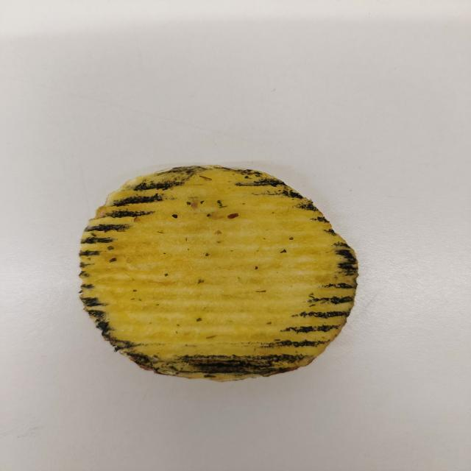

Fig 5.3.4.1 Bad quality chip Fig 5.3.4.2 Good quality Chip

### AUGMENTED DATASET

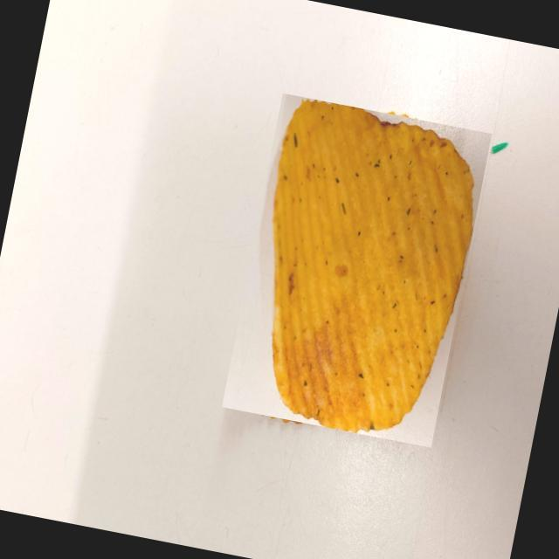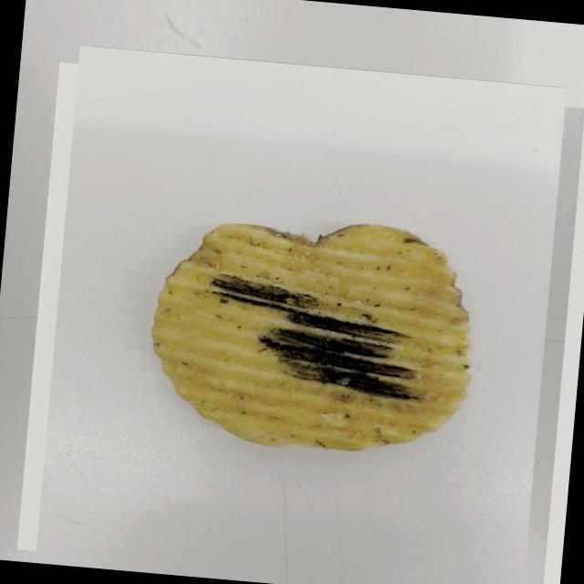

Fig 5.3.4.3 Bad quality Chip Fig 5.3.4.4 Good Quality Chip

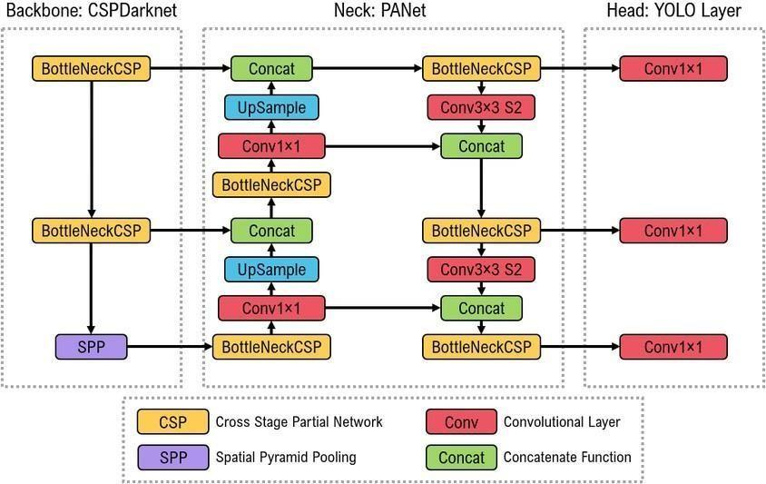

Fig 5.3.4.5 YOLO Architecture

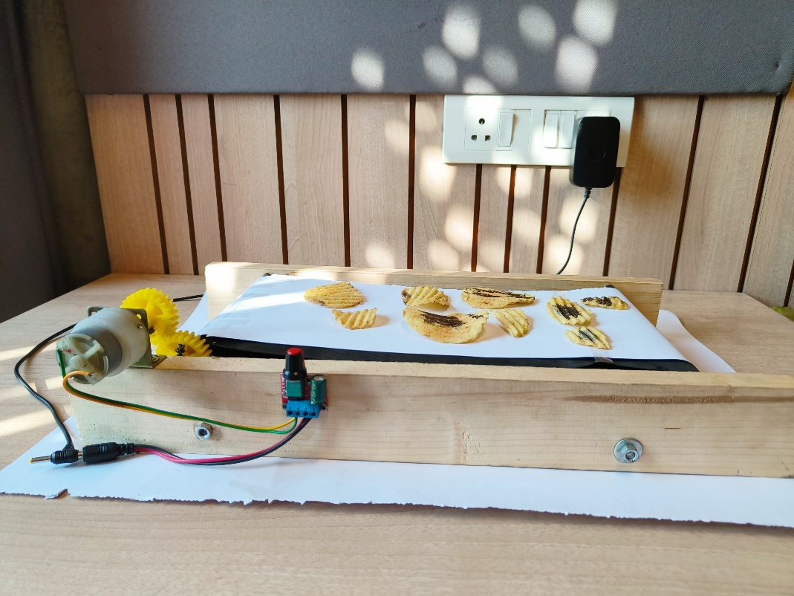

Fig 5.3.4.6 Chips placed on conveyor belt

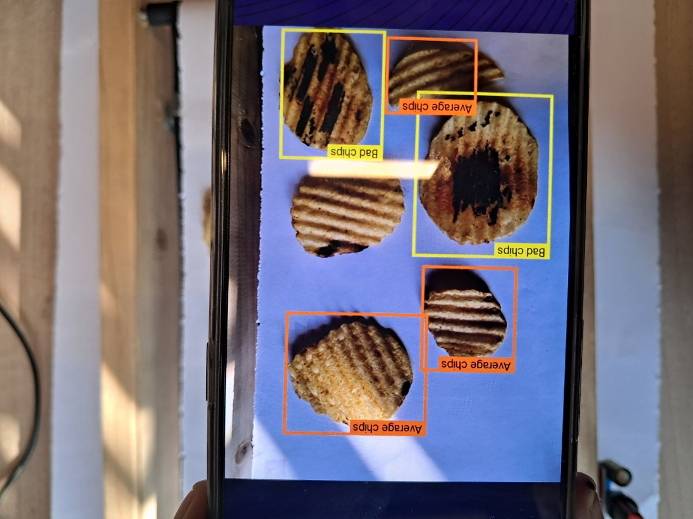

Fig 5.3.4.7 Predictions based on the model

## 5.4 Testing Process

Our plan is to test the whole system through the system we have created where we will test the features first, then a strategy has been chalked out, and ultimately the techniques for the testing process will be disclosed and discussed carefully. For specific purposes, we have used objects like chips and chocolates for detection and classifying them as good , average or bad. Therefore, we decided to test the model and its robustness on very specific edge cases which could be possible points of failures.

### Test Plan

**Testing of detection model:**

The model’s robustness is tested using different kind of object for classification.   
 **Testing of classification model:**

Our classification model is dynamic, whose testing can be done based on the dataset being used. The model parameters and layers are dynamic that is we can add or remove them based on our need. This makes our model much more robust. We have tested our model on lays the results are follows:

### 5.4.2 Features to be tested

The project deals with object segregation using deep learning models. We have tested for detection and classification of chips and chocolates. We need proper ample data which is properly labelled and contains the bounding boxes of desired objects. Finding such dataset will be the main requirement for testing of the model. Model may not provide good result in following conditions:

* + - * + Lack of properly labelled dataset with classified objects.
        + Improper scaling of the classification model due to which it might get stuck at some local minima’s.
        + Overlapping of chips might result into misclassification.

**5.4.3 Test Strategy**

We will be testing each module separately and after that we will test all the components together. Test strategy to validate the functionality of various system features like: training of classification and detection models.

**5.4.4 Test Techniques**

**Black box testing:** The tester interacts with user interface and provides inputs and checks outputs returned without going into the underlying code complexity.

**White box testing:** The tester investigates the internal logic and structure of the code and examines if every single component is working fine or not.

**Functional testing:** It involves testing the application against the business requirements. It incorporates all the test types designed to guarantee each part of piece of software behaves as expected by using use cases provided by the design team. The testing methods involve unit testing, integration testing, system testing and acceptance testing.

**Non-functional testing:** Non-functional testing methods incorporate all test types focused on the operational aspects of piece of software.

* + 1. **Test Cases**

Dataset creation:

The dataset being used must have the desired objects with bounded boxes with their proper inter-class classification. Format like .yaml is supported.

Data Augmentation:

The dataset must be augmented to increase the number of examples for training. Output after the augmentation process must not lose the aspect of detection and classification.

Training of Detection model:

The detection model that is our YOLOv5 must be able to detect the desired objects. The output of training model can be tested using parameters like IoU .

Training of Classification model:

The classification model is trained on the output of detection model. Thus, proper satisfaction of case 3 is need before moving on to test case 4. The output of classification model can be tested and verified using metrics like average precision.

### Test Results

The results were broadly positive according to the performance metrics that we have used. We take personal bias into account when it comes to choosing the performance metrics. We were able to detect the objects and we were able to classify the detected objects properly.

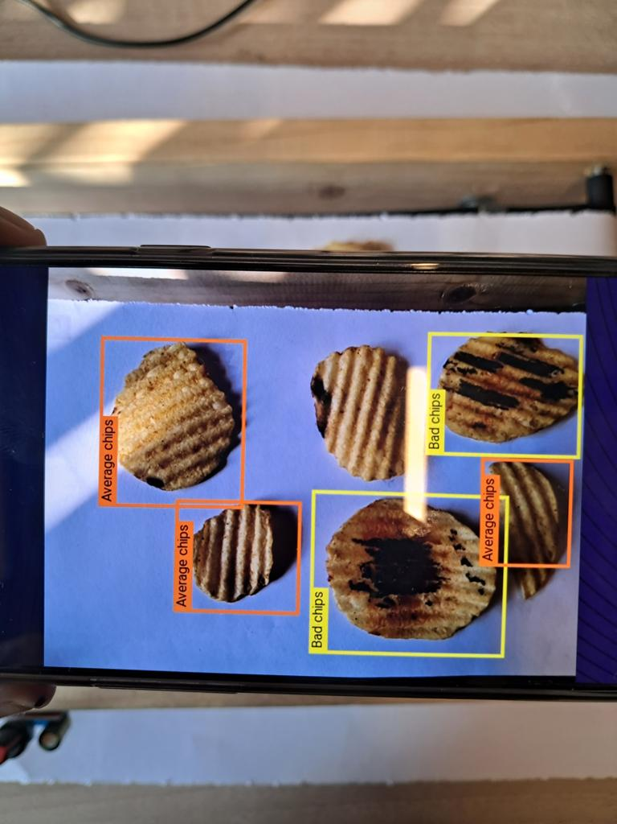

Fig 5.4.6.1 Testing the model

### 5.5 Results and Discussions

On comparing our combined model of YOLOv5 and custom trained classification model for both detection and classification, the YOLOv5 model gave higher average precision and recall and took less time to train. But our model took a smaller number of parameters and gave higher frame processing speed than the combined YOLOv5 package.

Further we were able to see that combined YOLOv5 package always find it difficult to classify objects that appear in groups. But we can train our customized model by passing images that specifically contain the objects that appear the in groups.

**5.6 Inferences Drawn**

Our customized model is able to perform well than the YOLOv5 model, and we can train it on versatile datasets. We combined good parts of both YOLOv5 and a customized classification model into a single project, which costs less and can be used for various purposes

The whole system has to be designed by making it very robust and user friendly so that the response time of the system as a whole is minimized to the lowest value possible. While the response time of code is within the tolerance limit, the other two components, the deployment and the hardware module have to be maintained in such a way that we get to mitigate the whole process time to the lowest value possible.

**5.7 Validation of Objectives**

Our main aim was to check all the main tasks of the system which we mentioned, hence effectively validating the whole process. Although we haven’t repeated our experiments, we have done it a few times.

* First part involves creating a model which can be used to for both detection and classification of the model. This step is achieved by the team and validated. But has a further scope of improvement in order to segregate more effectively if possible.
* Second objective was to create a hardware compatible interface with a camera for the real time analysis which has been achieved by the team.

# CONCLUSIONS AND FUTURE DIRECTIONS

## 6.1 Conclusion

In the culmination of our project, we have embarked on a journey to revolutionize quality control through the seamless integration of advanced technologies. Through a meticulous blend of innovative methodologies, deep learning concepts, and precision measurement techniques, we have successfully devised a comprehensive solution to address the critical challenge of product quality assurance.

Our project commenced with a thorough literature review, delving into the nuances of the YOLOV5 model and other deep learning models. This knowledge served as the foundation upon which we constructed our framework for quality control enhancement.

The heart of our approach lies in the intricate training of our YOLOV5. By utilizing a meticulously augmented dataset, we harnessed the power of machine learning to distinguish between objects, continuously refining our model's predictive accuracy. Through iterative training, we fostered model's ability to extract meaningful features and effectively classify objects—contributing to the improvement of our quality control mechanisms.

Critical to our success was the detection and classification of objects in real time. The coordinated efforts of our calibrated cameras and the YOLOv5 model's adeptness in object detection and classification seamlessly aligned to enable effective identification and classification of objects.

As the conveyor belt set into motion, our technological ecosystem sprung to life. Stereo cameras captured images, swiftly analyzed by the YOLOv5 model to return coordinates and images of detected objects which were further predicted as good, bad or average.

### 

### 6.2 Environmental, Economic, Social Benefits

* **Environmental Benefits:**

1. Waste Reduction: The accurate identification and segregation of defective products at an early stage significantly reduces the amount of waste generated during manufacturing. This leads to lower material consumption and a decreased environmental impact.
2. Energy Efficiency: By automating the process of quality control, the project contributes to energy efficiency by optimizing production processes and reducing the overall energy consumption.
3. Sustainable Manufacturing: The project's focus on detecting and classifying defective items ensures that only high-quality products proceed further in the manufacturing process. This minimizes resource wastage, conserves raw materials, and supports sustainable manufacturing practices.

* **Economic Benefits:**

1. Cost Savings: Identifying and eliminating defective products before they proceed through the entire production cycle saves substantial costs associated with rework, recalls, and customer complaints.
2. Increased Efficiency: Automation of quality control leads to increased production efficiency. It enhances throughput and overall productivity.
3. Enhanced Competitiveness: Improved product quality and consistency contribute to an enhanced brand reputation. This competitive advantage can lead to increased market share and higher customer trust, ultimately boosting revenue.

* **Social Benefits:**

1. Product Reliability: The project ensures that consumers receive products of consistent quality, enhancing their trust and satisfaction with the brand. This fosters positive customer experiences and loyalty.
2. Skilled Employment Opportunities: The project's implementation and maintenance require skilled professionals in areas such as deep learning, and automation. This creates employment opportunities and encourages the development of expertise in emerging technologies.
3. Technological Advancement: By combining cutting-edge technologies such as deep learning, and real time processing, the project contributes to technological advancements that have broader implications for various industries beyond quality control.

**6.3 Reflections**

1. Experimentation and Adaptation: The iterative experimentation approach was pivotal in fine-tuning our deep learning strategy. We observed the model's responsiveness to adjustments, contributing to increased accuracy over successive training cycles. Embracing an experimental mindset fosters adaptability and optimization in the dynamic field of deep learning.

2. Dataset Challenges: The quality and diversity of the dataset significantly impact model performance. Challenges were encountered in ensuring representative samples for robust training. Rigorous dataset curation and augmentation are crucial for model generalization. Striking a balance between diversity and specificity enhances model versatility.

3. YOLOV5 Scalability: The YOLOV5 model's scalability proved advantageous in handling different datasets and object types. However, careful consideration is required to maintain stability during training. Leveraging the scalability of YOLOV5 requires a nuanced understanding of model dynamics and training intricacies.

4. Roboflow Integration: The integration with Roboflow streamlined the dataset management process and facilitated efficient access to model predictions. Platform integration enhances workflow efficiency, underscoring the importance of selecting tools that complement the overall system architecture.

5. Real-world Challenges: Transitioning from controlled environments to real-world production settings presented unforeseen challenges, including variations in lighting and product positioning. Acknowledging and addressing real-world challenges during the development phase is essential for robust system performance.

6. User Feedback: Regular user feedback played a crucial role in refining the user interface and system functionality. Continuous engagement with end-users is instrumental in developing an intuitive and user-friendly system.

7. Areas for Improvement: Despite the project's successes, identified areas for improvement include enhancing real-time processing capabilities and exploring further automation in dataset management. Future iterations could focus on optimizing model deployment for faster real-time inference and incorporating additional automation in data preprocessing.

8. Collaborative Development: The collaborative development approach facilitated interdisciplinary insights, integrating domain knowledge into the technical aspects of the project. Cross-disciplinary collaboration enriches the project's outcomes, ensuring a holistic understanding and implementation.

**6.4 Future Work**

The project's current accomplishments lay a solid foundation for future work and enhancements. Here's a probable future work plan to build upon the existing framework and explore additional avenues:

1. Model Refinement: Continue refining the convolutional neural network (CNN) model for object classification. Explore advanced architectures and techniques to further improve accuracy and performance.

2. Data Expansion: Collect and incorporate more diverse and extensive datasets to enhance the model's ability to generalize across different scenarios and variations.

3. Transfer Learning: Investigate the potential of transfer learning by fine-tuning pre-trained models. This can expedite training and improve the model's performance on new classes of objects.

4. Real-time Analysis: Transition from batch processing to real-time analysis, enabling instantaneous detection and classification of objects as they move along the conveyor belt.

5. Robotic Arm Precision: Enhance the precision of the robotic arm's movements by incorporating feedback mechanisms and adaptive control strategies.

6. Object Tracking: Implement object tracking algorithms to follow and monitor objects in motion, ensuring accurate coordination between the robotic arm and detected objects.

7. Multiclass Segregation: Extend the project's capabilities to handle multiple classes of objects, enabling segregation based on a broader range of quality criteria.

8. Human-Machine Interaction: Develop user interfaces to facilitate interaction between operators and the system, enabling manual interventions when needed.

9. Quality Analytics: Implement data analytics to provide insights into the production process, identifying trends, patterns, and areas for further improvement.

10. System Scalability: Design the system to be modular and scalable, allowing easy integration with different conveyor systems and adaptable to varying production environments.

11. Integration with Manufacturing Systems: Integrate the quality control system with overall manufacturing processes to ensure seamless synchronization and optimize production workflows.

12. Sustainability Metrics: Quantify the environmental and economic impact of the project, tracking reductions in waste, energy consumption, and associated cost savings.

13. Human-Centered Design: Incorporate human-centered design principles to ensure that the technology interfaces smoothly with human operators and enhances their workflow.

14. Regulatory Compliance: Ensure that the project aligns with industry standards and regulations for quality control, safety, and product certifications.

15. Cross-Industry Application: Explore the applicability of the project's framework in diverse industries beyond manufacturing, such as logistics, agriculture, and healthcare.

16. Research Collaboration: Collaborate with research institutions to delve deeper into cutting-edge technologies, pushing the boundaries of innovation in quality control.

This future work plan outlines a trajectory for continuous improvement, innovation, and expansion of the project's scope. By addressing these areas, the project can evolve to meet the ever-changing demands of quality control and automation across various industries.

# PROJECT METRICS

## Challenges Faced

This project has pushed the boundaries of our thinking and perception, presenting unique challenges at every turn. From the initial task of convincing both mentors and team members to embark on such an ambitious endeavor to the final stages of completion, we have encountered hurdles that tested our resolve. Foremost among these challenges was the acquisition of a suitable dataset, a feat we ultimately achieved by creating our own.

Subsequently, we grappled with the intricate process of selecting an appropriate model, addressing the low accuracy issues, and seamlessly implementing it into our project. Coding-related challenges, including error resolution, added to the complexity of this phase.

Amid these technical obstacles, we also navigated the demanding landscape of our placement drive. Striking a balance between project commitments and preparation for job interviews introduced an additional layer of complexity to our journey. Nevertheless, the unwavering resilience and determination of our team played a pivotal role in overcoming these dual challenges.

## Relevant Subject

* + - ENGINEERING DESIGN PROJECT – I
    - ENGINEERING DESIGN PROJECT - II
    - SOFTWARE ENGINEERING
    - MACHINE LEARNING
    - FOUNDATIONS OF DATA SCIENCE
    - DATA SCIENCE APPLICATIONS - NLP, COMPUTER VISION AND IOT
    - DEEP LEARNING

## Interdisciplinary Knowledge Sharing

Our main aim is to control the quality of products supplied to the consumer. Our project can be majorly categorized into two parts. The first one comprises detecting the defective product based on the specified criteria after manufacturing. Our project involved a variety of discipline knowledge from computer engineering to Internet of Things .We learnt about YOLOV5 which fosters proficiency in computer vision, honing expertise in real-time object detection. The iterative process of improving model accuracy refines skills in data preprocessing, hyperparameter tuning, and understanding the nuances of the dataset. In essence, the learning outcomes from YOLOv5 extend beyond object detection, encompassing a spectrum of skills crucial for success in machine learning projects and applications.

## 7.4 Peer Assessment Metrics

## 

|  |  |  |  |  |  |
| --- | --- | --- | --- | --- | --- |
|  | **Khushi** | **Bhavya** | **Parush** | **Ishan** | **Anureet** |
| **Khushi** | **4** | **4** | **5** | **4** | **4** |
| **Bhavya** | **5** | **4** | **4** | **5** | **4** |
| **Parush** | **4** | **4** | **4** | **4** | **5** |
| **Ishan** | **4** | **5** | **4** | **4** | **4** |
| **Anureet** | **4** | **4** | **4** | **4** | **4** |

## 

## Table 7.4.1 Assessment Metrics

## 7.5 Role Playing and Work Schedule

|  |  |
| --- | --- |
| Name | Role |
| Khushi | Dataset preparation, Report work, related study regarding YOLOV5 |
| Bhavya | Dataset preparation, Report work, related study regarding YOLOV5 |
| Parush | Project Analysis and design, Video |
| Ishan | Data preprocessing, Poster, Fine tuning of Parameters |
| Anureet | Research finding, Poster, Fine tuning of Parameters |

## Table 7.5.1 Name and Role

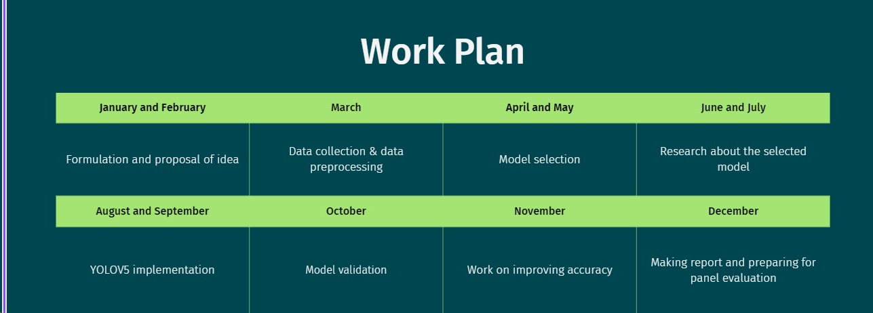

## Figure 7.5.1 Work Plan

## 7.6 Student Outcomes Description and Performance Indicators (A-K Mapping)

## 

|  |  |  |
| --- | --- | --- |
| **SO** | **Description** | **Outcome** |
| **A1** | Applying mathematical concepts to obtain analytical and numerical solutions. | Gradient, cross entropy, loss functions, optimization techniques |
| **A2** | Applying basic principles of science towards solving engineering problems. | Applying YOLOV5 |
| **A3** | Applying engineering techniques for solving computing problems. | Tested different methods to improve model accuracy. |
| **B1** | Identify the constraints, assumptions and models for the problems. | Using chips and chocolate images without them being overlapped. |

|  |  |  |
| --- | --- | --- |
| **B2** | Use appropriate methods, tools and techniques for data collection. | There was no pre-existing chips and chocolates dataset. The dataset used was created by capturing the images of different good,average and bad chips and chocolates from different angles. |
| **B3** | Analyze and interpret results with respect to assumptions, constraints and theory. | Testing the edge cases of every small activity included in the whole process. All the constraints were kept in mind while performing the test cases. |
| **C1** | Design software systems to address desired needs in different problem domains. | Designed the specified software system to fit the needs. |
| **D1** | Fulfill assigned responsibility in multidisciplinary teams. | Built the desired modules in separate teams. All the parts were done and managed well. |
| **D2** | Can play different roles as a team player. | At many times we helped each other at different phases of the project. |
| **E1** | Identify engineering problems. | Dataset collection and problem to develop a good accuracy model. |

|  |  |  |
| --- | --- | --- |
| **E2** | Use analytical and computational methods to obtain solutions | Train model for object classification and object detection. |
| **F1** | Showcase professional responsibility  while interacting with peers and professional communities. | Team conducted regular discussions with  the assigned mentor at regular intervals of period. |
| **F2** | Able to evaluate the ethical dimensions of a problem. | Yes, our problem identified was ethical as it helped those who need it the most. |
| **G1** | Produce a variety of documents such as  laboratory or project reports using appropriate formats. | Created the diagrams, documents, SRS and  the report as per the formats on the website. |
| **G2** | Deliver well-organized and effective oral presentations. | We presented our solution through  PowerPoint presentations and working models in the evaluations. |
| **H1** | Aware of the environmental and societal impact of engineering solutions. | The solution is having an overall positive impact on the environment and society. |
| **I1** | Able to explore and utilize resources to enhance self-learning. | Each member studied various online  courses to implement new and effective technologies in the project. |
| **I2** | Recognize the importance of life-long learning. | Team work, accomplishing work in limited time, presentation skills, technical skills, dealing with various errors with patience  will help us in future. |
| **J1** | Comprehend the importance of contemporary issues. | Yes, we reviewed a variety of cases regarding the similar issues and it made us |

|  |  |  |
| --- | --- | --- |
|  |  | more aware of such issues. |
| **K1** | Write code in different programming languages. | We used python. |
| **K2** | Apply different data structures and algorithmic techniques. | Various algorithms were used to optimize model parameters. |
| **K3** | Use software tools necessary for the computer engineering domain. | Roboflow, TensorFlow, Jupyter |

Table 7.6.1 A-K Mapping

**7.7 Brief Analytical Assessment**

### Q1. What sources of information did your team explore to arrive at the list of possible Project Problems?

**Ans 1** The group was aware of the understanding of the Capstone requirement and some of the problems that needed to be explored. We explored the literature, research papers, mostly journals and magazines from various organizations. Some part of the internet also played a part in arriving at the list of possible project problems

### Q2. What analytical, computational and/or experimental methods did your project team use to obtain solutions to the problems in the project?

**Ans 2.** Our project was divided into three parts consisting of creating the dataset, the ML model and improving its accuracy.

### Q3. Did the project demand demonstration of knowledge of fundamentals, scientific and/or engineering principles? If yes, how did you apply?

**Ans 3**. We used quite a lot of engineering subjects. Deep Learning, Machine Learning and Image Processing were used in building the ML model. We used python for implementing the YOLOV5 model and Roboflow for dataset creation and augmentation.

### Q4. How did your team share responsibility and communicate the information of schedule with others in the team to coordinate design and manufacturing dependencies?

**Ans 4**. Our team consisted of five members. We divided the project into subtasks, each individual carrying out specific tasks and helping out each in the processes. Information was communicated via whatsapp and zoom meetings. The meetings were also held offline in the library.

### Q5. What resources did you use to learn new materials not taught in class for the course of the project?

**Ans 5.** We took online tutorials and online courses. Moreover we read through various blogs, documentation and guides to learn the new concepts.

### Q6. Does the project make you appreciate the need to solve problems in real life using engineering and could the project development make you proficient with software development tools and environments?

**Ans 6.** Working on this project made us appreciate the need to solve real life problems using engineering. This project taught us a lot about new technologies and software engineering thereby making us proficient in the same.

# APPENDIX A: References

[1] Van Houdt, Greg & Mosquera, Carlos & Nápoles, Gonzalo. (2020). A Review on the Long Short-Term Memory Model. Artificial Intelligence Review. 53. 10.1007/s10462-020-09838-1.

[2] Chen, Sihong, Kai Ma, and Yefeng Zheng. "Med3d: Transfer learning for 3d medical image analysis." *arXivpreprint arXiv:1904.00625* (2019).

[3] Rogowski A, Skrobek P. Object Identification for Task-Oriented Communication with Industrial Robots. *Sensors*. 2020; 20(6):1773. https://doi.org/10.3390/s20061773

[4] "Robotic Grasping of Novel Objects using Deep Learning and Iterative Point Clouds" (2017)

# [5] M. Karthi, V. Muthulakshmi, R. Priscilla, P. Praveen and K. Vanisri, "Evolution of YOLO-V5 Algorithm for Object Detection: Automated Detection of Library Books and Performance validation of dataset,"2021 International Conference on Innovative Computing, Intelligent Communication and Smart Electrical Systems (ICSES), Chennai, India, 2021, pp. 1-6, doi: 10.1109/ICSES52305.2021.9633834.

# 

# [6] R.L. Williams II, “The Delta Parallel Robot: Kinematics Solutions”, Internet Publication, www.ohio.edu/people/williar4/html/pdf/DeltaKin.pdf, January 2016.

# 

# [7] Valladares, Sebastián & Toscano, Mayerly & Tufino, Rodrigo & Morillo, Paulina & Vallejo, Diego. (2021). Performance Evaluation of the Nvidia Jetson Nano Through a Real-Time Machine Learning Application. 10.1007/978-3-030-68017-6_51. [8] “Object detection using YOLO” (2022)-

# 

# [9] D. M. Tsai and S. K. Wu,Machine Vision Lab,Department of Industrial Engineering and Management,Yuan- Ze University, Chung-Li, Taiwan, R.O.C”Automated surface inspection using Gabor filters”.

# 

# [10] Sharma, A., Hua, G., Liu, Z. and Zhang, Z., 2008, June. Meta-tag propagation by co-training an ensemble classifier for improving image search relevance. In the 2008 IEEE Computer Society Conference on Computer Vision and Pattern Recognition Workshops (pp. 1-6). IEEE

**APPENDIX B: Plagiarism Report**

I, Ishan Mazumdar, affirm the originality and authenticity of the content presented in the document titled "DL-Powered Quality Control with a Delta Robot Arm". As one of the authors of this work and leader of the group, along with Anureet Kaur, Bhavya Gupta, Parush Garg and Khushi Bathla, I assert that every word, sentence, and idea contained within this document has been collectively created by us and reflects our own intellectual contributions. Throughout the process of crafting this document, we have meticulously upheld the principles of academic integrity by avoiding any form of plagiarism. This document is a manifestation of our collaborative research, creative thinking, and dedicated effort on our Capstone Group Project. We have conscientiously undertaken measures to verify the uniqueness of the content, ensuring that it remains distinct from any pre-existing works. Any semblance between this document and other works is purely coincidental, unintentional, and a testament to the shared exploration of the subject matter. We acknowledge the severe implications of plagiarism in academic and professional contexts, including its negative impact on the credibility of our work and the erosion of ethical values. We are committed to upholding the principles of academic honesty, integrity, and responsible scholarship. With the highest regard for intellectual authenticity, we submit this document as an authentic representation of our own contributions.

Date: 21.08.2023

Signatures: